

**Module Project I**

**Project Name**

**Project ID**

**Name Surname, Student ID**

Sivas Science and Technology University

Department of Electric Electrical Engineering

20.05.2025

INSTRUCTIONS

*The reports will be submitted by [16-19 May].*

*Presentation submissions will also be made along with the report submission. Reports will be submitted via email and in hard copy.*

*The language of both the report and the presentation will be English.*

*The presentation duration will be 10 minutes.* Prepared circuit setup will be presented as part of the allocated presentation time.

*Presentations should be prepared with PowerPoint and supported by visuals.*

*The use of artificial intelligence and similarity detection will be conducted.*

**To Do List**

### 1. Determining the Project Topic

### 2. Project Plan and Circuit Diagram

* Review the LM741 datasheet and learn the connection diagram you will use.
* Draw the circuit diagram and prepare a list of components.

### 3. Acquisition of Required Materials

* LM741 op-amp integrated circuit
* Resistors (with values suitable for your design)
* Capacitors (if needed)
* Connecting wires
* Breadboard or PCB
* Power supply (e.g., 5V or 12V adapter)
* Multimeter and oscilloscope (for testing)

### 4. Theoretical Calculations

* Calculate the required gain and resistor values for your adder or subtractor circuit.
* Determine the theoretical values of input and output voltages.

### 5. Circuit Assembly

* Assemble the components on a breadboard or PCB.
* Carefully check all connections and ensure there are no short circuits or incorrect connections.

### 6. Testing the Circuit

* Connect the power supply to the circuit and turn it on.
* Apply input signals (e.g., DC or AC) to the circuit.
* Measure the output signals and compare them with theoretical values.

Project Details

|  |  |
| --- | --- |
| **Project Name** | **Project Name** |
| **Circuit Type** | **Specify which circuit type you used** |
| **Name, Surname** | **Kağan Purlu** |
| **Student Id Number** | **12345678** |
| **e-mail** | **kagan.purlu@sivas.edu.tr** |
| **Name2, Surname2** |  |
| **Student Id Number2** |  |
| **e-mail2** |  |
| **Academic Advisor** | **Instructor Name, with full title** |
| **Github URL** | **Github URL** |
| **WEB page** | **(if applicable, if not leave it empty)** |

Individual Contributions Overview

|  |  |
| --- | --- |
| **Name, Surname** | **Summary of Contributions to the Modul Project Document** |
| Kağan | Main responsible of the Document Formatting  Contributed to Executive Summary, Requirements and System Model  Main responsible for all design, simulation and installation of the circuit |
| Arda | Main responsible of the Document Formatting  Contributed to Executive Summary, Requirements and System Model  Main responsible for all design, simulation and installation of the circuit |
| Berke | Main responsible of the Document Formatting  Contributed to Executive Summary, Requirements and System Model  Main responsible for all design, simulation and installation of the circuit |

Executive Summary

Text, maximum 1 page, no images.

This section provides a brief overview of your Module Project, and your major findings and most important things that your Executive should notice / read.

Table of Contents

**Page Number**

The table of contents should be automatically created by MS Word.

List of Tables

**Page Number**

The list of tables (if any) should be automatically created by MS Word.

List of Figures

**Page Number**

The list of figures (if any) should be automatically created by MS Word.

Abbreviations

|  |  |
| --- | --- |
| CMRR  Vcc | Common-Mode Rejection Ratio  Supply Voltage |
| Vout | Output Voltage |
| SNR | Signal-to-Noise Ratio |
| *Abbreviations need to be alphabetically ordered* |  |
|  |  |
|  |  |
|  |  |
|  |  |
|  |  |
|  |  |
|  |  |
|  |  |
|  |  |
|  |  |
|  |  |

# Scope

**Text Format:** All text in your document should use the Cambria font, size 12pt, with 1.5 line spacing, and paragraphs justified.

**What to Write in This Section?**

Define the general scope of your project. Specify the areas of focus related to operational amplifiers (OpAmps), such as basic principles, applications, or design aspects.If there are topics intentionally excluded from the scope, briefly explain them.

**Note:** It is recommended to write this section after completing the document. This will allow you to better summarize the activities you have performed and the areas you have intentionally left out.

# Project Schedule

This section should specify the work packages required for the project, their dependency relationships, resource requirements, and the allocation of budget and resources to work packages. The project schedule should also include defined milestones and goals.

## Work Packages & Dependencies

First, clearly define all the work packages in the project and the tasks that need to be completed within each package. Each work package should be uniquely identified using a numbering scheme or descriptive title. It is recommended to use a **Work Breakdown Structure (WBS)** diagram to illustrate the hierarchical relationships between tasks and subtasks within work packages. This will facilitate easier project management and progress tracking.

Additionally, this section should explain the sequencing relationships between work packages and any dependencies on external events. Techniques such as dependency lists, dependency tables, activity networks, or the **Critical Path Method (CPM)** can be used to represent these dependencies. This will clearly show the relationships between tasks and ensure a structured approach.

Each work package should include detailed milestones and deliverables. For example, the key milestones of the project can be defined as follows:

* **Milestone 1:** Solving the relevant part of the project using Calculus.
* **Milestone 2:** Solving the relevant part of the project using Physics.
* **Milestone 3:** Simulating and designing the relevant part of the project using Circuit I

## Resource Requirements

This subsection should detail the time-based estimates of resources required to complete the project. Resource requirements include the number and types of team members (e.g., students, advisors) and the equipment, facilities, and services needed throughout the project duration.

Focus should be placed on the following resources:

* **Personnel:** The roles and number of team members required for tasks such as research, design, and implementation should be specified.
* **Computing Resources:** Estimates should include computer usage time, support software, and hardware requirements. Special tools, such as simulation or design software, should be explicitly mentioned.
* **Facilities:** The use of office spaces, laboratory access, or other physical facilities should be detailed.
* **Maintenance:** Ongoing costs, such as software licenses, equipment maintenance, or consumables used during the project, should be outlined.

**Table 1.** Table captions need to be on top of the table

|  |  |  |  |  |
| --- | --- | --- | --- | --- |
| **Info** | **Project A** | **Project B** | **Project C** | **Project D** |
|  |  |  |  |  |
|  |  |  |  |  |
|  |  |  |  |  |
|  |  |  |  |  |
|  |  |  |  |  |
|  |  |  |  |  |

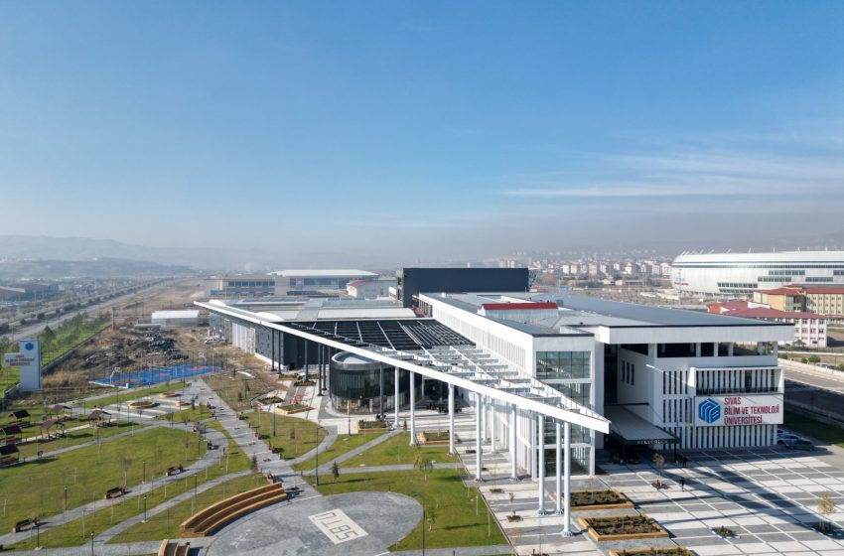

**Figure 1.** Figure captions need to be below the figure

# Course Contributions and Project Effort

In this section, describe how the project was carried out by applying knowledge and techniques learned from various courses. Focus on how each course contributed to solving specific challenges and completing different aspects of the project. Calculations, coding, and graphs obtained as a result of the project should be appropriately explained and presented with suitable visuals. It should be stated that the results, methods, and techniques were obtained in alignment with the projected goals and objectives of the project. The results section should include the research design, dependent and independent variables, and statistical methods. The following courses are particularly relevant and should be referenced in detail:

## Calculus

Explain how mathematical concepts from **Calculus** were used to model, analyze, and solve technical problems within the project. Discuss where calculus was specifically applied, such as in analyzing signal behavior, optimizing system performance, or calculating precise measurements for circuit components.

## Physics

Highlight how knowledge from **Physics** was utilized to understand and implement fundamental principles within the project. For example, discuss the application of laws of electricity, magnetism, and mechanics in designing and simulating operational amplifier circuits or other physical components of the system.

## Circuit I

Discuss how **Circuit I** contributed directly to the core aspects of the project. This may include designing, simulating, or testing circuits, understanding the operation of components like operational amplifiers (OpAmps), and ensuring the system functions as intended. Mention specific tools or techniques learned in Circuit I that were instrumental to the project.

## Algorithm and Programming

Describe how programming skills and algorithmic thinking were applied to the project. This could include coding simulations, developing software to interface with the designed circuits, or automating calculations. Emphasize how logical problem-solving and structured programming facilitated the successful completion of tasks.

## ****Integration and Overall Effort****

Discuss how the knowledge from these courses was integrated to complete the project as a whole. Reflect on the effort required to combine theory with practical application and how each course's contributions supported different stages of the project. Comment on which areas were most challenging and how these challenges were addressed using the interdisciplinary knowledge gained from the courses.

## ****Discussion****

Reflect on the overall effort estimation and the contribution of each course to the project. Discuss which course provided the most significant support for completing the project and why. Analyze how the integration of concepts from multiple disciplines made the project more efficient or effective. Finally, evaluate whether the applied knowledge was sufficient for the project goals or if further learning or external resources were required to overcome challenges.

# Discussions

In this section, the challenges encountered while preparing the **Software Project Management Plan (SPMP)** for **Operational Amplifiers (OpAmps)** should be discussed, along with how these challenges were addressed. For instance, technical difficulties in translating theoretical knowledge into practice, lack of resources, or issues in team communication can be highlighted. Additionally, explain how knowledge from various courses contributed to overcoming these challenges: **Calculus** for creating mathematical models, **Physics** for applying physical principles, **Circuit I** for circuit design and analysis, and **Algorithm and Programming** for simulations and automation processes. Evaluate which methods were effective during the process, which parts required more time and effort, and draw insights for future projects.

## Limitations and Constraints

List the limitations and constraints encountered during your work. For example, time limitations, lack of resources, or challenges in accessing technical knowledge.

## Health and Safety Issues

Mention any health and safety concerns experienced during your work, such as prolonged screen time or risks associated with equipment usage.

## Legal Issues

Discuss any legal requirements or considerations related to your work, such as intellectual property rights or regulatory compliance.

## Economic Issues and Constraints

Describe the economic aspects of your project, including the cost of tools and materials used or any budget constraints faced.

## Sustainability

List any sustainability-focused actions undertaken during the project, such as energy-saving measures, the use of recyclable materials, or efficient resource management.

## Ethical Issues

Discuss any ethical challenges encountered during your work, such as fair task distribution, academic integrity, or conflicts of interest.

## Multidisciplinary Collaboration

Explain how knowledge and techniques from different disciplines were integrated during your project. For example, combining concepts from electronics, software, and physics to develop solutions.

## Real-World Problem Solving

Reflect on the real-world problems your project aims to solve. For instance, precise signal processing in the defense industry, optimization in communication technologies, or innovations in automation processes.

## Alignment with Industry Applications

Evaluate how your project aligns with industry sectors such as defense, automotive, energy, or telecommunications. Discuss which problems it addresses and what contributions it could make to these fields.

# References

|  |  |
| --- | --- |
| [1] | A Guide to the Project Management Body of Knowledge, Project Management Institute, 2021. |
| [2] | J. Pinto, Project Management: Achieving Competitive Advantage, 5 / Golbal ed., Pearson, 2019. |